POS & Inventory Management System

1. Title
Integrated Point of Sale (POS) and Automated Inventory Management System of NICOLLE GROCERY STORE

2. The Problem
Small to medium-sized retail businesses often struggle with manual tracking, leading to:
- Inventory Inaccuracy: Discrepancies between physical stock and recorded data.
- Operational Inefficiency: Slow checkout processes due to manual product lookups.
- Financial Loss: Undetected product expirations and stockouts of best-selling items.
- Lack of Insight: Difficulty in identifying sales trends or calculating real-time profit.

3. UML Use Case Diagram Explanation
The Use Case diagram illustrates the interaction between the users and the system's core functionalities.
- Primary Actors:
  - Cashier: Focuses on the "Front-End" operations like scanning products, managing the cart, processing payments (Cash, Card, Digital Wallet), and generating receipts.
  - Admin: Handles the "Back-End" management, including inventory updates, tracking expiration dates, and analyzing business metrics via the dashboard.
- Key Relationships:
  - Include/Extend: The "Process Payment" use case extends into specific methods (Digital Wallet, etc.), while "Generate Receipt" is a mandatory inclusion after a successful checkout.
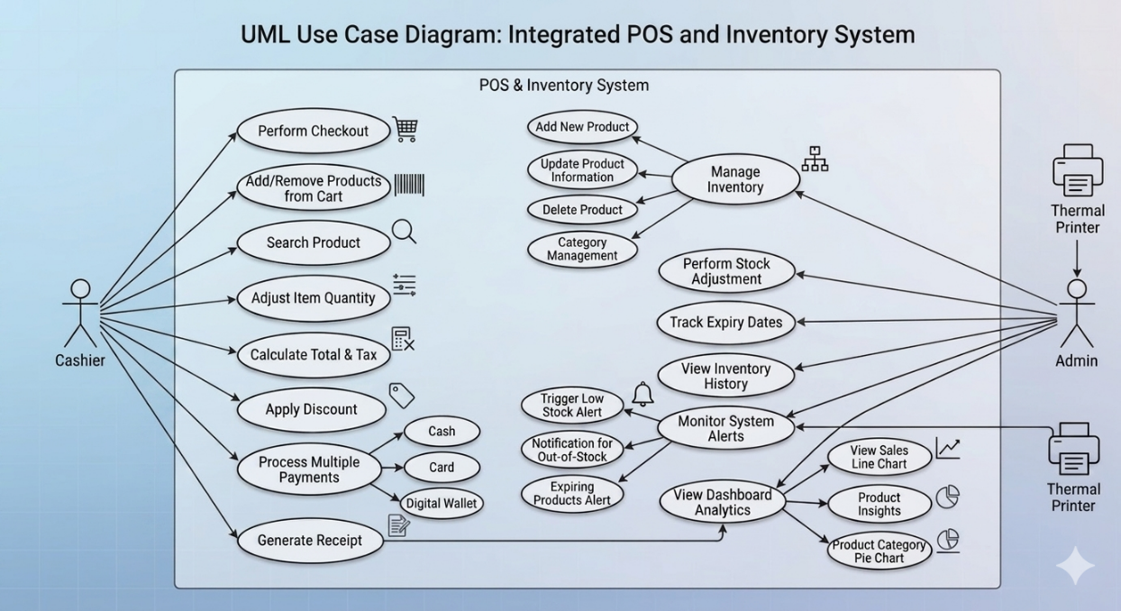
  - System Boundary: All automated alerts (Low Stock, Expiring Products) are internal system processes that notify the Admin actor.

